OLD HEN HOUSE, ST AGNES
Booking Form
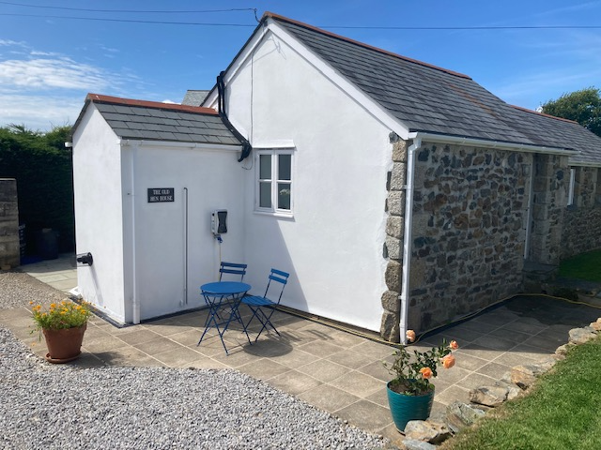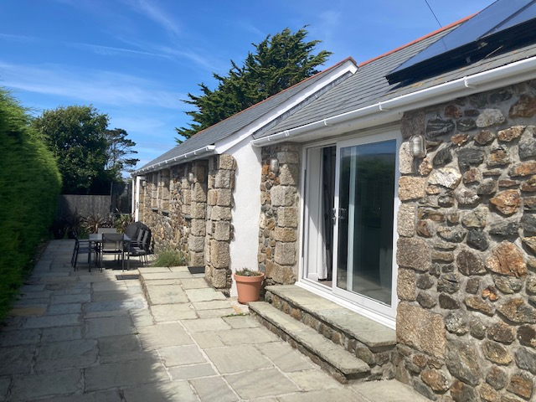
YOUR NAME:
YOUR ADDRESS:
EMAIL ADDRESS:
TELEPHONE NUMBER:
RESERVATION DATES:
PLEASE ENSURE YOU HAVE CONFIRMED THESE DATES ARE AVAILABLE
Number in the party:
Adults Teenagers Children Babies (<2yrs)

Other names of people in the party (and ages of those under 16)
1:
2:
3:
Are you bringing a dog? (This requires prior arrangement; see the small print)
(If yes please indicate: ONE / TWO)
How did you hear about the Old Hen House?

Airbnb www.visitstagnes.com Google search Other
Please indicate if you require optional extras:
(You can decide / confirm these details closer to your holiday… this is just for indication.)
- Cot and cot sheet (free)
- Cot side (free)
- High chair (free)
- Evening meal of day of arrival (This requires prior arrangement.)
- Arrangement of veggie boxes etc and/or acceptance of supermarket delivery (This requires prior arrangement.)
CALCULATIONS FOR PAYMENTS
Total cost of holiday as advertised (A) £
Deposit required with this booking form (=0.3 x total cost of hols) (B) £
(We will provide you with BACS transfer details to enable you to pay online within 7 days of the booking being emailed to us.)
Balance of payment: (= 0.7 of total cost of hols) (A - B = C) £
Any dogs? (If Yes, add £30 per week / £5 per day per dog) (D) £
Add £150 security / damage deposit (refundable) (E) £ 150.00
TOTAL BALANCE TO PAY: (C + D + E) = £
Balance due date: (Six weeks prior to holiday):
DECLARATION:
I confirm that I am over 18 years of age and agree to pay the balance of payment for this booking at the Old Hen House six weeks prior to the arrival date.

I confirm that I have read and accept the terms and conditions of our stay.

Signed: Date:
NAME:
PLEASE SCAN THIS BOOKING FORM AND EMAIL IT TO Carolyn.Garman@gmail.com
BACS TRANSFER: Mrs Carolyn A Garman; Sort Code 30-98-76; Account Number 21334968

